**WELCOME ABOARD**

|  |
| --- |
| **Detachment #**  **MARINE CORPS LEAGUE** |

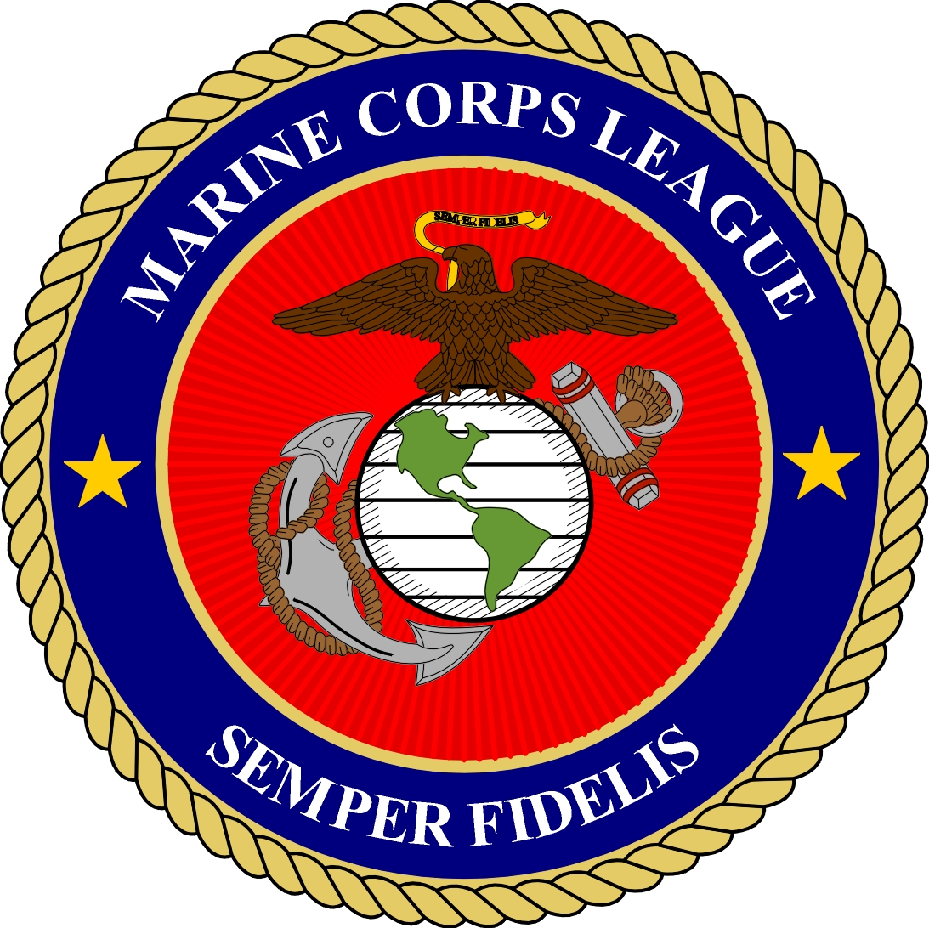

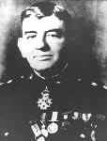  
General John A. Lejeune

The Marine Corps League was founded by General John A. Lejeune in 1923, receiving its national Charter by an Act of Congress on August 4, 1937. The League is classified as a veterans/military service organization whose purpose is to promote the interests and preserve the traditions of the U. S. Marine Corps; assist fellow Marines, their widows and orphans and participate in various patriotic ceremonies. This detachment falls under the Department of Missouri and within the Midwest Division, National Headquarters Marine Corps League.

The league is comprised of honorably discharged as well as reserve and active duty Marines and FMF Navy Corpsmen with over 90 days of service. Those individuals that want to participate with the Marine Corps League but do not otherwise qualify may join as Associate Members.

**Mission Statement**

|  |
| --- |
| img |
| [Click here to edit your page](http://www.orgsites.com/az/oldbreed767/_pgg1.php3?APedit=)[Click here to go to your office](http://www.orgsites.com/az/oldbreed767/_modules.htm) |

Waving_Flagmcflagflyingpowmiaclr

Members of the Marine Corps League join together in camaraderie and fellowship for the purpose of preserving the traditions and promoting the interests of the United States Marine Corps, banding together those who are now serving in the United States Marine Corps and those who have been honorably discharged from that service that they may effectively promote the ideals of American freedom and democracy, voluntarily aiding and rendering assistance to all Marines and former Marines and to their widows and orphans; and to perpetuate the history of the United States Marine Corps and by fitting acts to observe the anniversaries of historical occasions of particular interest to Marines.

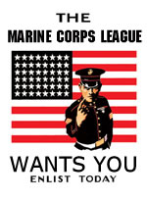

**Purposes of the Marine Corps League**

|  |
| --- |
| img |
| [Click here to edit your page](http://www.orgsites.com/az/oldbreed767/_pgg1.php3?APedit=)[Click here to go to your office](http://www.orgsites.com/az/oldbreed767/_modules.htm) |

s

**To preserve** the traditions, promote the interest, and perpetrate the history of the United States Marine Corps and, by fitting acts, to observe the anniversaries of historical occasions and of particular interest to Marines.

**To band** those who are now serving the United States Marine Corps and those who have been honorably discharged from that service together in fellowship, that they may effectively promote the ideals of American freedom and democracy.

**To fit** its members for the duties of citizenship and to encourage them to serve ably as citizens as they have served our nation under arms.

**To hold** sacred the memory and history of men who have given their lives to the nation.

**To foster** love for the principles that they have supported by blood and valor since the founding of the Republic.

**To maintain** true allegiance to American institutions.

**To aid** voluntarily, and to render assistance to all Marines, uniformed and civilian, as well as to their widows and orphans

**History of the Marine Corps League**

|  |
| --- |
| img |
| [Click here to edit your page](http://www.orgsites.com/az/oldbreed767/_pgg1.php3?APedit=)[Click here to go to your office](http://www.orgsites.com/az/oldbreed767/_modules.htm) |

The Marine Corps League perpetuates the traditions and spirit of ALL Marines and Navy FMF Corpsmen, who proudly wear or who have worn the eagle, globe and anchor of the Corps. It takes great pride in crediting its founding in 1923 to World War I hero, then Major General Commandant John A. Lejeune. It takes equal pride in its Federal Charter, approved by An Act of the Seventy-Fifth Congress of the United States of America and was signed and approved by President Franklin D. Roosevelt on August 4, 1937. The League is the only Federally Chartered Marine Corps related veterans organization in the country. Since its earliest days, the Marine Corps League has enjoyed the support and encouragement of the active duty and Reserve establishments of the U. S. Marine Corps. Today, the League boasts a membership of nearly 61,000 men and women, officer and enlisted, active duty, Reserve Marines, honorably discharged Marine Veterans and qualified Navy FMF Corpsmen and is one of the few Veterans Organizations that experiences increases in its membership each year.

The Marine Corps League is headed by an elected National Commandant, with 14 elected National Staff Officers who serve as trustees. The National Board of Trustees coordinates the efforts of 48 department, or state, entities and the activities of over 900 community-based detachments located throughout the United States and overseas. The day-to-day operations of the League are under the control of a Chief Operating Officer with the responsibility for the management and direction of all programs, activities, and affairs of the Marine Corps League as well as supervising the National Headquarters staff.

The prime authority of the League is derived from its Congressional charter and from its annual National Convention held each August in different major U.S. cities throughout the nation. It is a not-for-profit organization within the provisions of the Internal Revenue Service Code 501(c) (4), with a special group exemption letter which allows for contributions to the Marine Corps League, its Auxiliary and subsidiary units, to be tax deductible by the donor.

**Programs of the Marine Corps League**

|  |
| --- |
| img |
| [Click here to edit your page](http://www.orgsites.com/az/oldbreed767/_pgg1.php3?APedit=)[Click here to go to your office](http://www.orgsites.com/az/oldbreed767/_modules.htm) |

**MARINES HELPING MARINES - WOUNDED MARINES PROGRAM**

The program was created to support injured Marine Corps personnel located at the National Naval Medical Center in Bethesda, Maryland, Walter Reed Army Medical Center in Washington, DC, Brooke Army hospital in San Antonio, as well as the Naval Hospitals at Balboa, Camp Pendleton and elsewhere. The Wounded Marines Program works closely with the Wounded Warrior Regiment. The scope of support encompasses; financial support, visits from Marine Corps League members, off site day trips to include family outings, dinners, short trips in support of the individual Marines’ needs and professional sporting events as tickets and opportunities present themselves.

**U. S. MARINES YOUTH PHYSICAL FITNESS PROGRAM**

The League developed and administers a program that provides a physical fitness regimen that promotes a healthy, drug free life style for elementary and high school students.

**YOUNG MARINES OF THE MARINE CORPS LEAGUE**

A youth program emphasizing honesty, courage, respect, industry, loyalty, dependability, and a sense of devotion to God, country, community and family. The Young Marines program receives funding from Congress and the United States Marine Corps primarily because of their drug interdiction focus on drug education and prevention.

**SCHOLARSHIP PROGRAM**

Members of the Marine Corps League fund scholarships through donations from individual members and subordinate units of the Marine Corps League and Auxiliary. Children and former Marines are eligible for academic scholarships for attendance at accredited colleges and universities.

**LEGISLATIVE PROGRAM**

The Marine Corps League is a member of The Military Coalition and participates in National and State legislative issues that affect military readiness, benefits and entitlements of active duty personnel as well as Veterans Benefits programs effecting former and retired Marines.

**VETERANS SERVICE OFFICER PROGRAM**

The National Headquarters retains a full-time staff member who assists veterans in adjudicating claims against the government as a result of active duty service. Claims are processed through the Department of Veterans Affairs or other appropriate agencies of the federal government.

**VETERANS AFFAIRS VOLUNTARY SERVICE PROGRAM (VAVS)**

Marine Corps League members contribute thousands of man-hours each year supplementing staffs at VA Hospitals and facilities in providing morale, comfort and assistance to institutionalized veterans.

**MARINE CORPS LEAGUE AUXILIARY**

The Auxiliary was formed: To Preserve the traditions and promote the interests of the United States Marine Corps; To maintain true allegiance to American institutions; To hold sacred the history and memory of the men and women who have given their lives to this Nation; To perpetuate the history of the United States Marine Corps and by fitting acts, to observe the anniversaries of historical occasions of particular interest to Marines; To create a bond of comradeship between the Auxiliary and the Marine Corps League; To aid voluntarily and to render assistance to all Marines and former Marines as well as to their families; To help decorate the graves of all deceased Marines whenever and wherever possible; To strive for the passage of legislation favorable to the Marine Corps League, Inc. and to the United States Marine Corps and its personnel; To always foster love of Honesty, Loyalty and Truth, and a reverence to our God, Our Country, Our Family and Our Home.

**MILITARY ORDER OF DEVIL DOGS**

The fun and honor society of the Marine Corps League.

**TOYS-FOR-TOTS**

Marine Corps League Detachments in nearly every community take part annually in the United States Marine Corps Reserve Toys-For-Tots campaign to raise funds and collect and distribute toys to needy children. In communities where there is an existing Marine Corps Reserve Unit, the League works hand in hand supporting their campaign. In other communities, the Marine Corps League takes the lead, ensuring a successful campaign.

**BOY SCOUTS OF AMERICA**

The Marine Corps League has long regarded the program of the Boy Scouts of America as in support of the Preamble of the Constitution of the League. The League supports the Boy Scouts of America as they promote traditional family values to America’s youth. The Marine Corps League participates in Scouting through assistance with units, districts, and councils, in community projects, merit badge programs, and special recognition of Eagle Scouts.

**MARINE-4-LIFE/INJURED MARINE SUPPORT PROGRAM**

The League works very closely with the Marine Corps’ M-4-L program, providing mentors nationwide. In areas of the country where there is no Marine Corps “point of contact”, the League works directly with M-4-L Headquarters to provide services to transitioning Marines.

**Marine Corps League Foundation**

The Marine Corps League Foundation is the charitable subsidiary of the Marine Corps League. The Foundation, was formed in 1989 as a non-profit 501c(3) educational and charitable entity for the Marine Corps League. The Foundation has grown considerably in recent years because of your generous support of the Holiday Label program. Your generosity has greatly enhanced the Foundation's ability to support the scholarship and youth programs of the Marine Corps League.   
  
The Foundation is incorporated in the Commonwealth of Virginia as a non-profit charitable organization and has been granted 501c(3) tax exempt designation by the IRS. The Foundation is administered by a board of seven directors who are appointed by the National Commandant with the advise and consent of the National Board of Trustees of the Marine Corps League. Contributions to the foundation are tax deductible.   
  
To learn more about the Marine Corps League Foundation please visit the organization's website at http://www.mclfoundation.org/.

**ANNUAL CONVENTIONS**

Members find the State and National Conventions of the League ideal vacation venues for themselves and family members. Held in a different city each year, many families attend year after year and particularly enjoy the many planned activities and tours related to these get-togethers.

The Marine Corps League is a charter member of The Military Coalition, The National Marine Corps Council, AdHoc Committee, Navy and Marine Corps Council, the National Veterans Day Committee, and is represented on countless committees and programs serving the military and veteran community.

The League participates in patriotic functions such as the National Memorial Day Parade and the National 4th of July Parade in Washington as well as countless statewide and community parades around the country. We provide representation to the U.S. Congress in legislative matters affecting the United States Marine Corps, national security and veteran’s benefits through our National Legislative Committee. Most importantly, Marine Corps League Detachments are actively involved in Community based programs throughout the country.

**Marine Corps League National Website**

[**www.mcleague.org**](http://www.mcleague.org)

**Marine Corps League Library Website**

[**https://www.mcleaguelibrary.org/**](https://www.mcleaguelibrary.org/)

**Uniform Items**

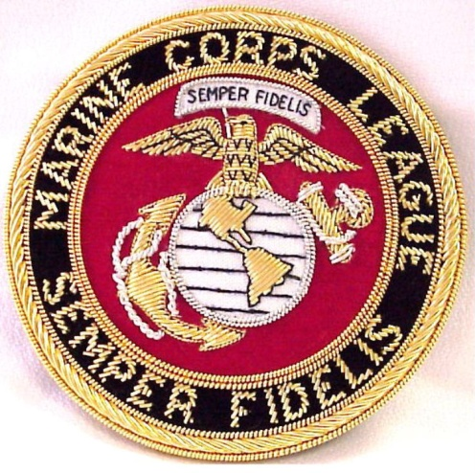 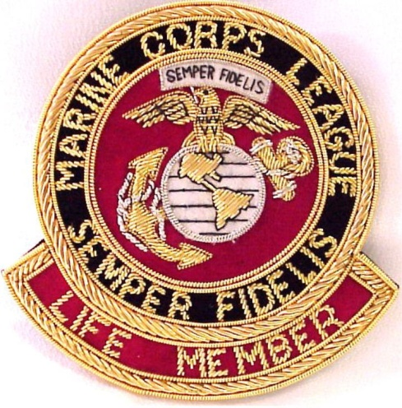

Marine Corps League Crest Marine Corps League Life Member Crest

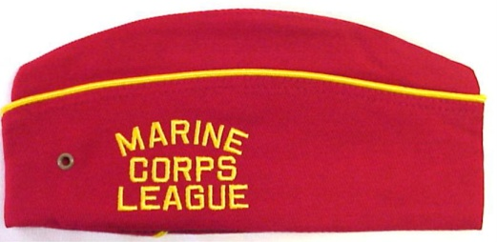 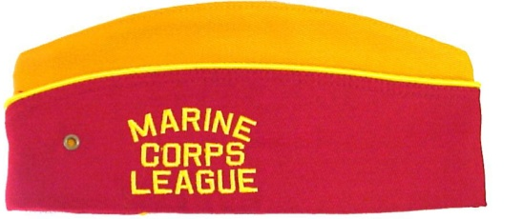

Detachment Member Cover Department Officer Cover

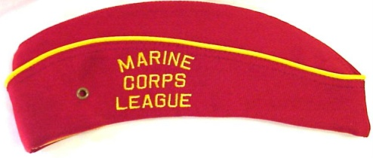 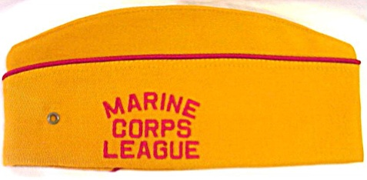

Detachment Woman Member Cover National Officer Cover

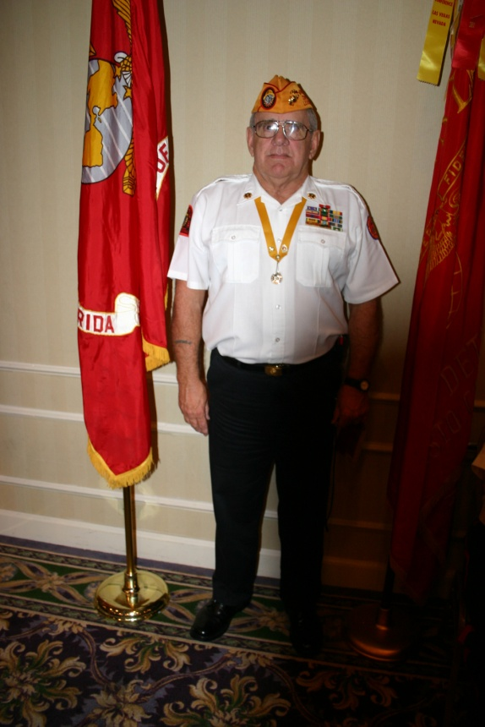

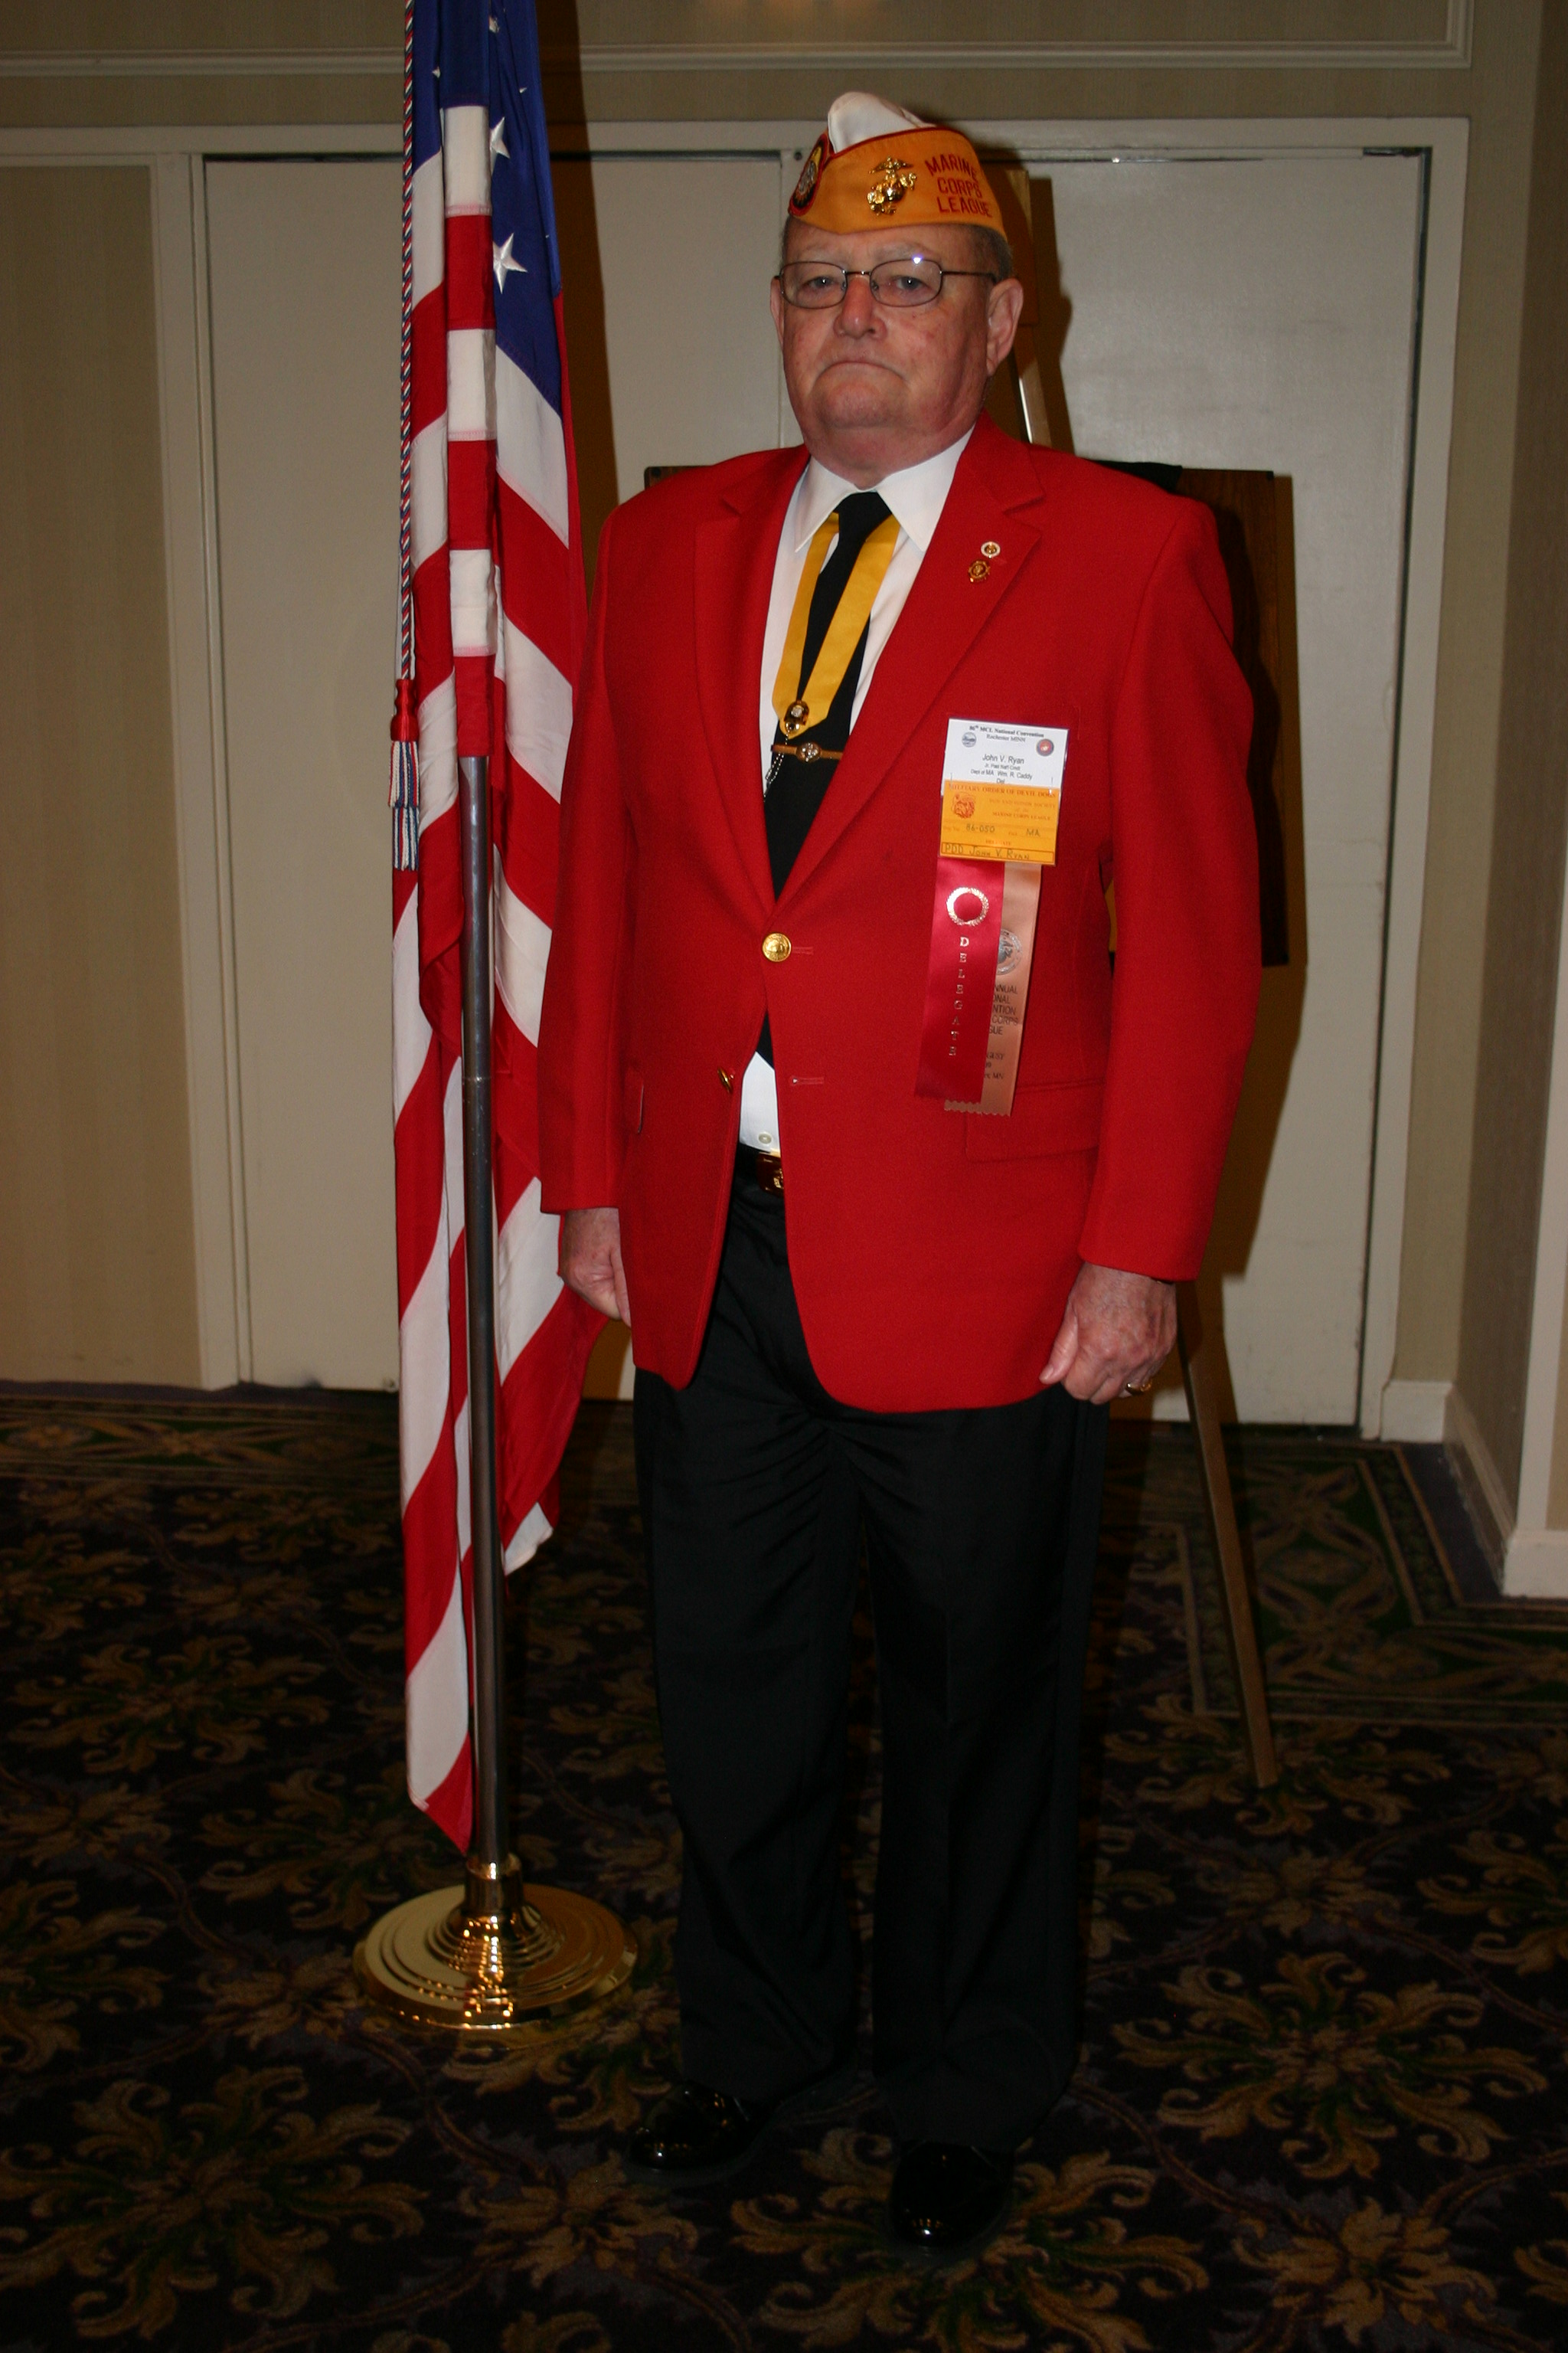

**Trousers**

Black or

Marine Corps Dress Blue with Blood Stripe

**Left Breast**

DoD Ribbons **or**

Marine Corps League Ribbons

**DO NOT MIX DoD AND MCL RIBBONS**

**Left Shoulder**

Marine Corps League Patch

**COLLAR Insignia**

Star Burst on each collar anchor turned inward.

**SHIRT**

White Aviator shirt with epaulets

**Belt**

Black Leather with Marine Corps League buckle or

Kaki Web belt with Dress Blue Trousers

**Ribbon Around Neck**

Either MODD Tag or

Marine of Year Medal

**Cannot wear both at same time**

**Right Shoulder**

Devil Dog patch or American Flag with blue field forward

**National Officer Cover**

Devil Dog Patch Right Side

Eagle Globe and Anchor Left Side.

**NO PINS ARE TO BE WORN ON COVER**

Meeting Protocol

|  |
| --- |
| img |
| [Click here to edit your page](http://www.orgsites.com/az/oldbreed767/_pgg1.php3?APedit=)[Click here to go to your office](http://www.orgsites.com/az/oldbreed767/_modules.htm) |

The Northwest MO Detachment # 180 Meets: Second Tuesday of every month.

Meeting location: American Legion Post # 287

501 E Price Ave

Savannah, MO 64485

Meeting Time: 19:00

The Marine Corps League operates under the Roberts Rules of Order to maintain order and discipline during the meeting. We are not to discuss politics or religious matters during the meeting partially because of their volatility and we are not authorized to speak for the Marine Corps League on these matters.

During the meeting if a member wishes to address the floor on any topic he or she is to rise, salute and address the Commandant as Sir or Madam Commandant, state his or her name, and wait to be recognized before he or she begins talking. This is for common courtesy and to help maintain order. No member should speak over another who has the floor but wait his or her turn to speak.

The Uniform of the day is at the desecration of the Commandant. The cover is required to be worn indoors because that is the minimum Marine Corps League uniform.

**If you are wearing your cover you are in uniform.**

Most Detachments only asks the members to wear casual civilian attire and their cover during their monthly business meetings. The membership may wear other Marine Corps League Uniforms if they wish, but if they do they must wear it properly. If the detachment is having a special occasion or an important person attending the Commandant may ask the membership to wear a specific uniform to the event.

**Yes we wear our covers indoors and salute indoors!!!**

**It feels unusual when you first start but you will get accustomed to it!**

Uniform Accessories

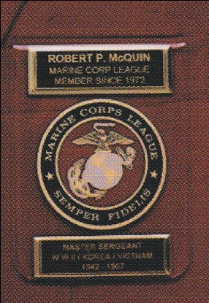 Alternate Pocket Crest

Black Trousers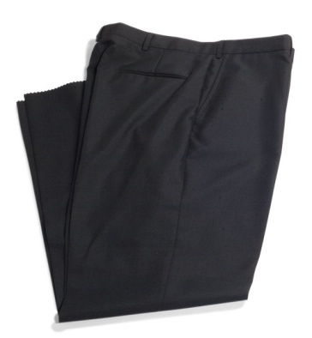Black Tie 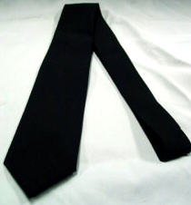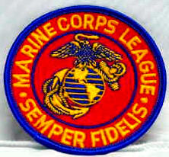 Patch

Cover Emblem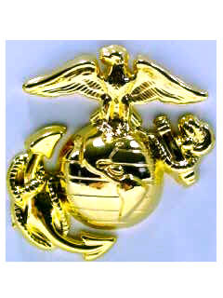Collar Insignias

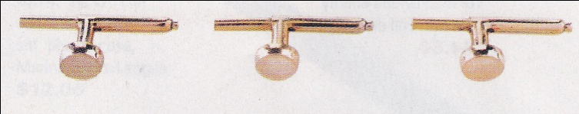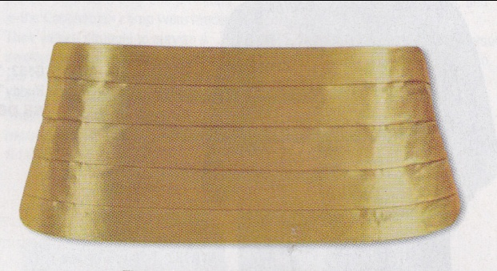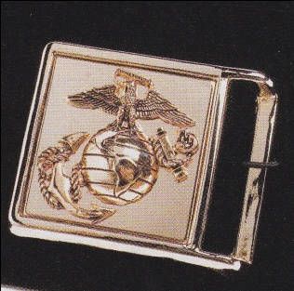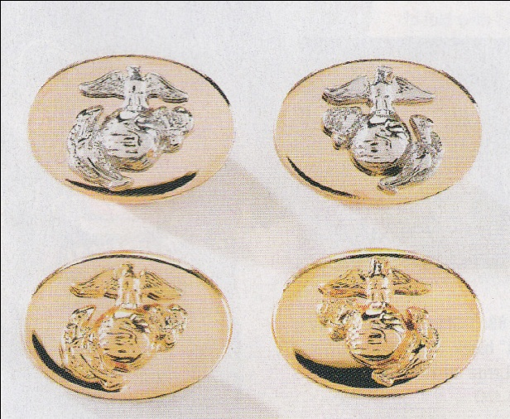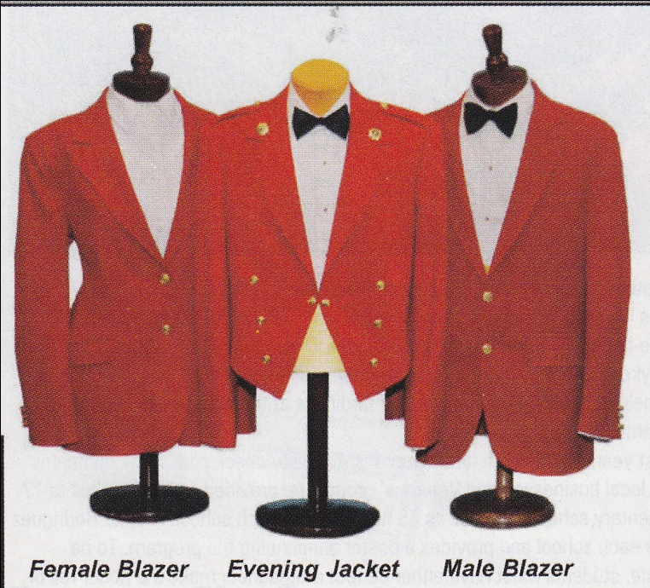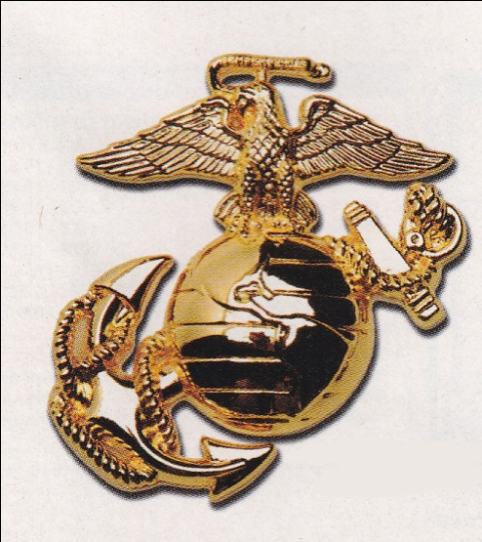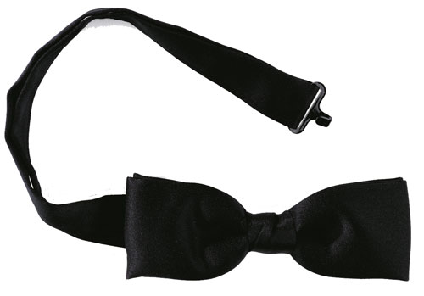

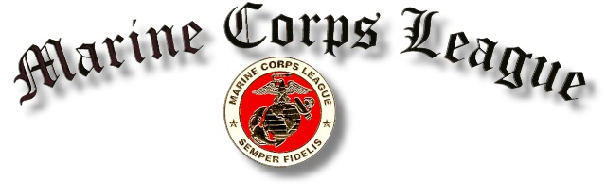

**Please check one box below:**

This information may be used for Internal Marine Corps League Correspondence only.

This information may be distributed to other members of the Marine Corps League.

Please bring this back to the next meeting or mail it to:

Gerald A. Moorehead Adjutant/Paymaster, Larry Nehring Detachment Marine Corps League,

PO Box 5303, Des Moines, Iowa 50305-5303

\***None of this information will be given or sold to the Public or Any Other Organization.**

**(Please write or print legibly)**

**Other Organizations Affiliated With and Offices Held:**

(use extra sheet of paper if necessary)

**Military Information:**

Dates of Service: \_\_\_\_\_\_\_\_\_\_\_\_\_\_\_\_\_to \_\_\_\_\_\_\_\_\_\_\_\_\_\_\_\_\_Last Rank:\_\_\_\_\_\_\_\_\_\_\_\_\_\_\_\_\_

Units served with:\_\_\_\_\_\_\_\_\_\_\_\_\_\_\_\_\_\_\_\_\_\_\_\_\_\_\_\_\_\_\_\_\_\_\_\_\_\_\_\_\_\_\_\_\_\_\_\_\_\_\_\_\_\_\_\_\_\_\_\_\_

\_\_\_\_\_\_\_\_\_\_\_\_\_\_\_\_\_\_\_\_\_\_\_\_\_\_\_\_\_\_\_\_\_\_\_\_\_\_\_\_\_\_\_\_\_\_\_\_\_\_\_\_\_\_\_\_\_\_\_\_\_\_\_\_\_\_\_\_\_\_\_\_\_\_\_\_

Duty stations:\_\_\_\_\_\_\_\_\_\_\_\_\_\_\_\_\_\_\_\_\_\_\_\_\_\_\_\_\_\_\_\_\_\_\_\_\_\_\_\_\_\_\_\_\_\_\_\_\_\_\_\_\_\_\_\_\_\_\_\_\_\_\_\_\_

\_\_\_\_\_\_\_\_\_\_\_\_\_\_\_\_\_\_\_\_\_\_\_\_\_\_\_\_\_\_\_\_\_\_\_\_\_\_\_\_\_\_\_\_\_\_\_\_\_\_\_\_\_\_\_\_\_\_\_\_\_\_\_\_\_\_\_\_\_\_\_\_\_\_\_\_

**Personnel Info:**

Nick Name: \_\_\_\_\_\_\_\_\_\_\_\_\_\_\_\_\_\_\_\_Birth date:\_\_\_\_\_\_\_\_\_\_\_\_ Anniversary:\_\_\_\_\_\_\_\_\_\_\_\_\_

Spouse Name:\_\_\_\_\_\_\_\_\_\_\_\_\_\_\_\_\_\_\_\_\_\_\_\_\_\_\_\_\_\_\_\_\_\_\_\_\_\_\_\_\_\_\_\_\_\_\_\_\_\_\_\_\_\_\_\_\_\_\_\_\_\_\_

Children Names and Ages: \_\_\_\_\_\_\_\_\_\_\_\_\_\_\_\_\_\_\_\_\_\_\_\_\_\_\_\_\_\_\_\_\_\_\_\_\_\_\_\_\_\_\_\_\_\_\_\_\_\_\_\_\_

\_\_\_\_\_\_\_\_\_\_\_\_\_\_\_\_\_\_\_\_\_\_\_\_\_\_\_\_\_\_\_\_\_\_\_\_\_\_\_\_\_\_\_\_\_\_\_\_\_\_\_\_\_\_\_\_\_\_\_\_\_\_\_\_\_\_\_\_\_\_\_\_\_\_\_

Name Last:\_\_\_\_\_\_\_\_\_\_\_\_\_\_\_\_\_\_\_\_\_\_\_\_\_\_\_\_\_First:\_\_\_\_\_\_\_\_\_\_\_\_\_\_\_\_\_\_\_\_\_\_\_\_MI:\_\_\_\_\_\_

Address:\_\_\_\_\_\_\_\_\_\_\_\_\_\_\_\_\_\_\_\_\_\_\_\_\_\_\_\_\_\_\_\_\_\_\_\_\_\_\_\_\_\_\_\_\_\_\_\_\_\_\_\_\_\_\_\_\_\_\_\_\_\_\_\_\_\_\_\_

City:\_\_\_\_\_\_\_\_\_\_\_\_\_\_\_\_\_\_\_\_\_\_\_\_\_\_\_\_\_\_\_\_\_\_\_\_\_\_\_\_\_\_\_State:\_\_\_\_\_\_\_\_\_\_\_\_\_\_\_\_\_\_\_\_\_\_\_\_

Phone #:\_\_\_\_\_\_\_\_\_\_\_\_\_\_\_\_\_\_\_\_\_\_\_\_\_\_\_\_e-mail:\_\_\_\_\_\_\_\_\_\_\_\_\_\_\_\_\_\_\_\_\_\_\_\_\_\_\_\_\_\_\_\_\_\_\_

**Military Order of**

**the Devil Dogs**

**Military Order of the Devil Dogs  
Honor Society of the Marine Corps League**



# DEVIL DOG'S CREED:

**I am an American: I was born in France. I have held the title of United States Marine, and understand the commitment of holding the title, Devil Dog. It is a tradition born at Belleau Wood in the year 1918, of a Force In Readiness and the "First To Fight". As a Devil Dog, I ask no quarter and give no quarter. I will do everything in my power to uphold the objectives of the Military Order of Devil Dogs and to carry out my duties to a swift and satisfactory completion.**

**The Military Order of the Devil Dogs is the fun and honor society of the Marine Corps League.**

# Main Purpose:

**Promotes good fellowship amongst the members of different Marine Corps League Detachments. The Order provides amusement and entertainment at all gatherings of the League, when and where advisable, preserves and strengthens the principles and ideals of the League, and maintains true allegiance to the United States of America and its Constitution and laws. It fosters and extends American institutions of freedom and defends America against all enemies foreign and domestic. The Order is also VERY active in raising funds for children's hospitals, and associated charities.**





# Who Belongs:

**The Military Order of Devil Dogs is made up only of Members of the Marine Corps League. The Order only accepts the most worthy of League Members.**

# How to Join:

**You must be a paid-up member in good standing in the Marine Corps League. The applicant must be active in his/her Detachment in the League, and must request membership in the Order. He/She must be recommended by the Detachment Commandant and be sponsored by two Devil Dogs or Pedigreed Devil Dogs. The applicant is then interviewed by the members of the Pound at a Pound Growl (a meeting is called a Growl). If accepted, the applicant must undergo an initiation and swearing-in ceremony.**

# Organization:

**The Pound is on a local level and is usually made up of members of different Marine Corps League Detachments. On the State level there is the Pack, and on the National level there is a Kennel. There are three different degrees in the Order. The lowest degree is that of a Pup. The next degree is that of a Devil Dog. The highest degree is that of a Pedigreed Devil Dog. The Pup wears a black ribbon, the Devil Dog wears a red ribbon, and the Pedigreed Devil Dog wears a gold ribbon. The ribbon is worn around the neck and a Dog Tag is attached to it.   
  
The head of the Pound is called the Pound Keeper. The head of the pack is the Pack Leader. The head of the Kennel is also the head of all Devil Dogs and is called Chief Devil Dog.   
  
The Order's many charitable donations not only help people in need, but also build good public relations for the Order, the League, and the United States Marine Corps.**

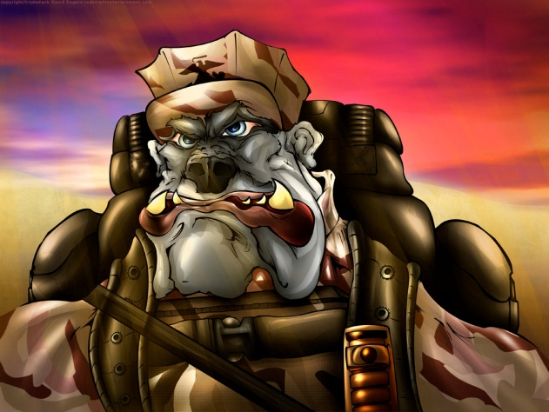

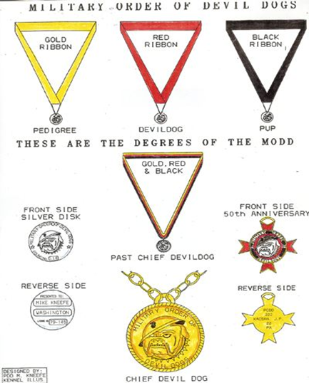

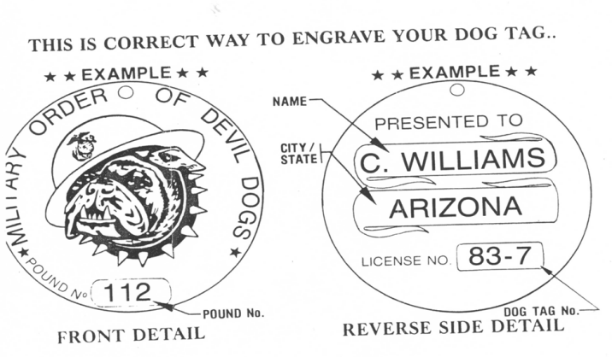 dvldog