

Welcome Aboard

Wardogs Pound #110

Missouri Pack

Welcome to the Military Order of Devil Dogs, Wardogs, Pound#110, Missouri Pack.

Remember that only Marine and FMF Corpsmen (regular members) in good standing with the Marine Corps League and one continuous year will be recommended by (2) DD’s or PDD’s and then be validated by their Detachment Commandant to become a member. We are only interested in quality membership, not quantity. It is an honor and a privilege to be a Devil Dog.

There will be quarterly business meetings that are called Growls to discuss business at hand, initiate new members and to have a good time. The election of pound officers will be held yearly. During the Growls we will also discuss events and activities that we would like to arrange throughout the year for members and their families to enjoy.

**We are to keep the business light and the enjoyment heavy.**

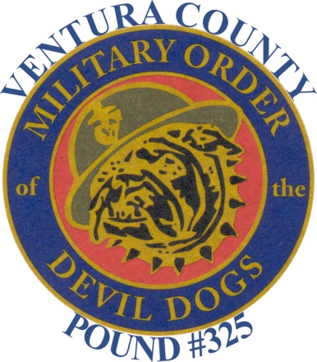

**\*\*\***Non-members of the Military order of Devil Dogs, Inc. are permitted ONLY to witness opening ceremonies and the obligation of newly elected officers. Non-members **SHALL NOT** observe, attend or witness any other portion of the order's Growls or ceremonies."

***“This booklet is the property of the MODD and this booklet is for the private personal use of MODD members and this information is not to be released to the general public."***

What is it:   
The Military Order of Devil Dogs is the fun and honor society of the Marine Corps League.

What it does:  
It promotes good fellowship amongst the members of different Marine Corps League Detachments. The Order provides amusement and entertainment at all gatherings of the League, when and where advisable. It assists in the accomplishment of all programs and objectives of the League, preserves and strengthens the principles and ideals of the League, and maintains true allegiance to the United States of America and its Constitution and Laws. It fosters and extends American institutions of freedom and defends America against all enemies whatsoever. The Order is also VERY active in raising funds for different charities.

Who Belongs:  
The Military Order of Devil Dogs is made up only of members of the Marine Corps League. The Order only accepts the most worthy of League members.

How to Join:  
You must be a paid-up member in good standing in the Marine Corps League. The applicant must be active in his/her Detachment in the League and will be invited to join. He or she must be recommended by the Detachment Commandant and be sponsored by two Devil Dogs or Pedigreed Devil Dogs.

Organization:  
The Pound is on a local level and is usually made up of members of different Marine Corps League Detachments. On the State level there is the Pack, and on the National level there is a Kennel. There are three different degrees in the Order. The lowest degree is that of Pup. The next degree is that of Devil Dog. The highest degree is that of Pedigreed Devil Dog. The Pup wears a black ribbon, the Devil Dog wears a red ribbon, and the Pedigreed Devil Dog wears a gold ribbon. The ribbon is worn around the neck and a Dog Tag is attached to it.  
The head of the Pound is called the Pound Keeper. The head of the Pack is the Pack Leader. The head of the Kennel is also the head of all Devil Dogs and is called Chief Devil Dog.   
The Order's many charitable donations not only help people in need, but also build good public relations for the Order, the League, and the United States Marine Corps.

**Devil Dog Creed**

I am an American, I was born in France. I have held the title of United States Marine, and understand the commitment of holding the title, Devil Dog. It is a tradition born at Belleau Wood in the year 1918, of a “Force In Readiness” and the “First To Fight”. As a Devil Dog, I ask no quarter and give no quarter. I will do everything in my power to uphold the objectives of the Military Order of the Devil Dogs and to carry out my duties to a swift and satisfactory completion.

**MILITARY ORDER OF THE DEVIL DOGS**

**DICTIONARY OF LANGUAGE**

**Honorable Chief Devil Dog -------- National Commandant**

**Worthy Pack Leader ---------------- Department Commandant**

**Sir Pound Keeper -------------------- Detachment Commandant**

**Sr. Vice Pound Keeper --------------- Detachment Sr. Vice Commandant**

**Jr. Vice Pound Keeper --------------- Detachment Jr. Vice Commandant**

**Dog Robber ---------------------------- Adjutant/Paymaster**

**Smart Dog ----------------------------- Judge Advocate**

**Dog Trainer --------------------------- Chaplain**

**Police Dog ----------------------------- Sgt-at-Arms**

**Watch Dog ------------------------------Asst. Sgt-at-Arms. Checks registrations & passports.**

**Mad Dog ------------------------------- Initiation Officer**

**Barking Dog -------------------------- Public Relations**

**Junk Yard Dog ------------------------ Quartermaster for ships store**

**Please note that the above positions also exist at department and national levels with a few exceptions.

**KENNEL ------------------------------- National Level**

**PACK ----------------------------------- State Level**

**POUND ----------------------------------Local Level**

**DOG HOUSE -------------------------- Meeting Place**

**SUPREME GROWL -----------------**